Output of 2D Rotation
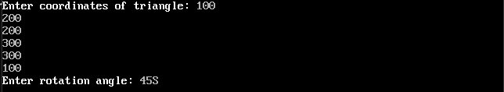
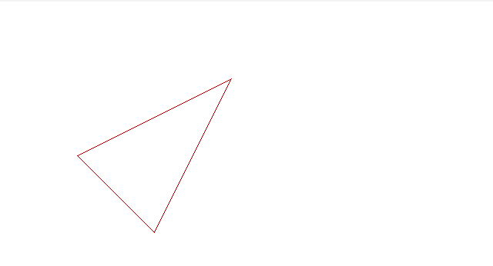

Output of 2D Translation
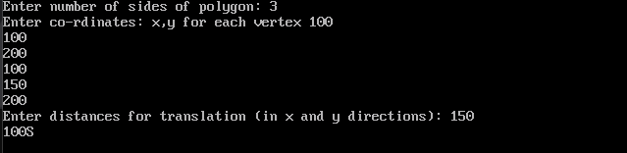
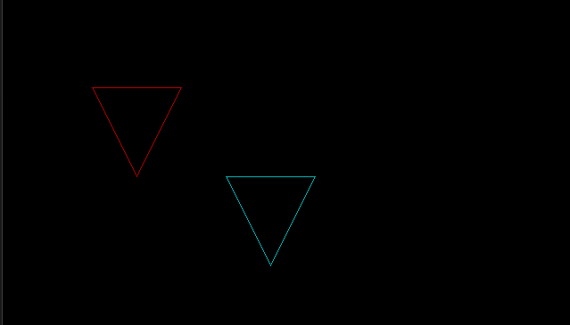

Output of 3D Scaling
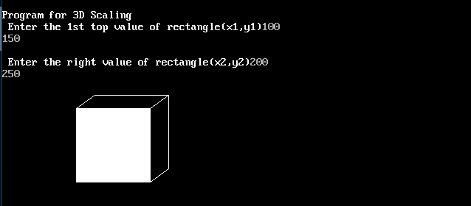
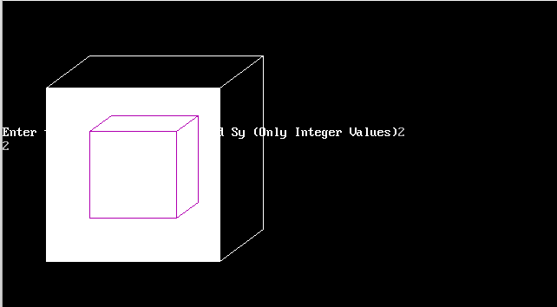

Output of Boundary Fill
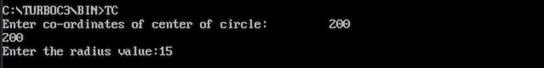




Output of Bresline Algorithm
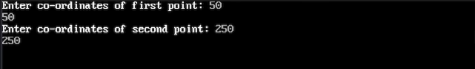
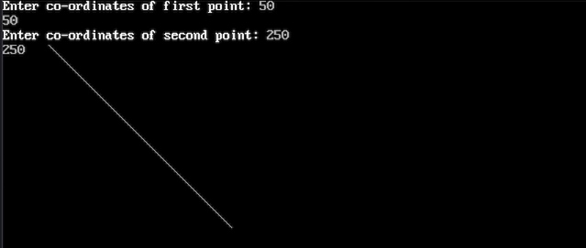

Output of Digital Differential Analyzer Line Drawing Algorithm
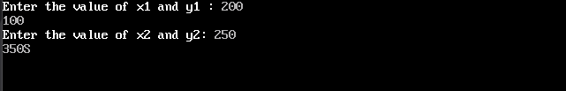
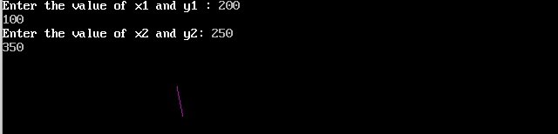
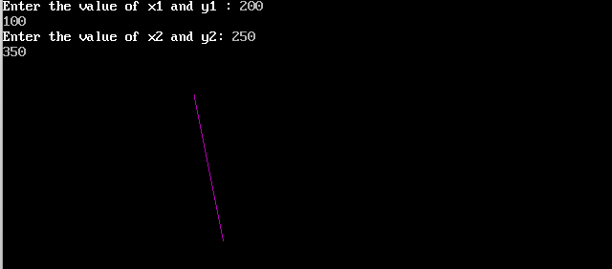

Output of Midpoint Circle Drawing Algorithm
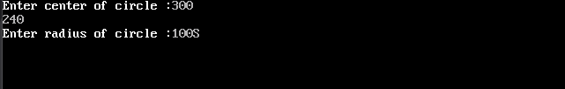
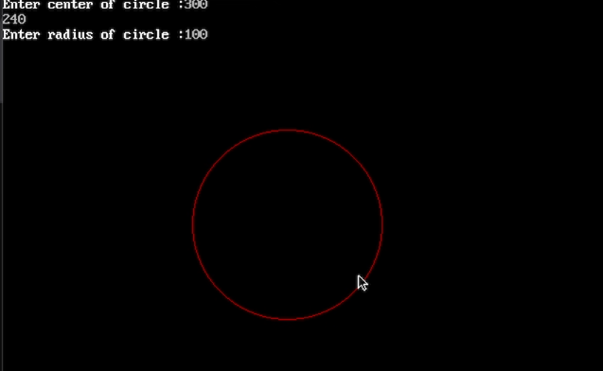

Output of Midpoint Ellipse Drawing Algorithm
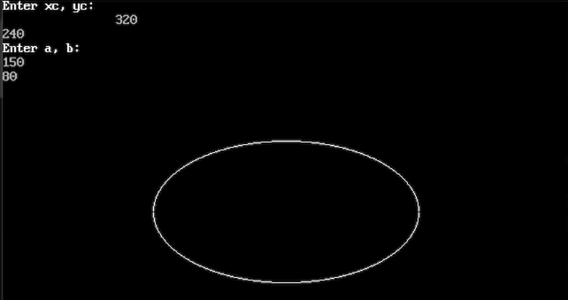

Output of Moving Car
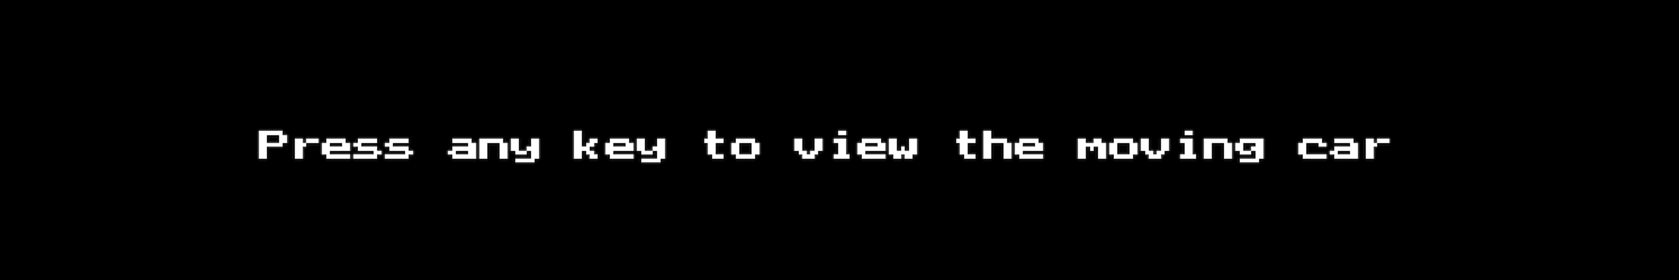
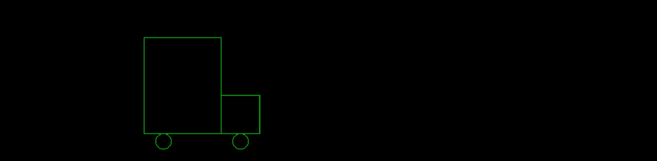
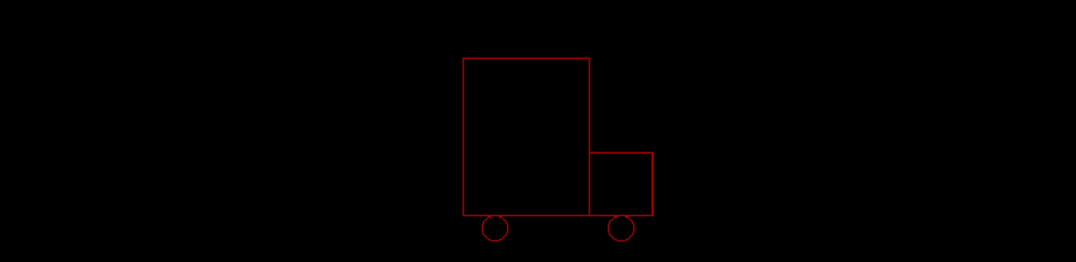
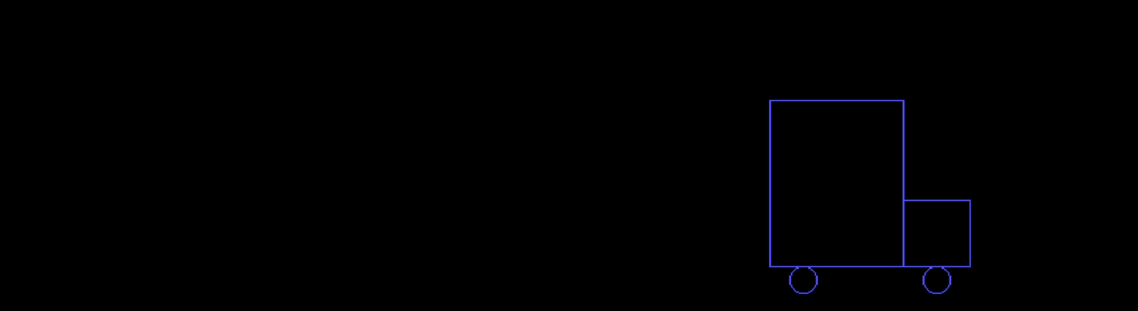

Output of Scan Line Polygon Fill Algorithm
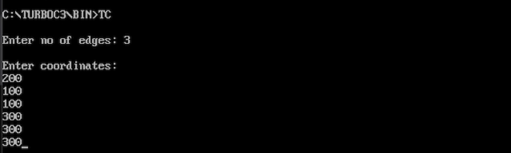
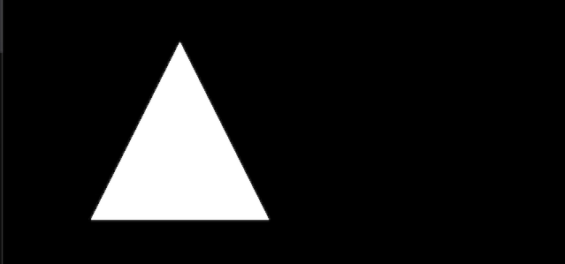

Output of Smiley Face
